Department of Computer Science and Engineering (Data Science)
CSDS-A | Batch A1 (CSE - Data Science, Section A)
AI Health Insurance Assistance Using LLM + RAG
(PolicyLens)
S.No. | Student name | Roll / hall ticket no.
1 | G.PRANATHI | 23K91A6764
2 | CH.AISHWARYA | 23K91A6747
3 | BHAVANSH MANE | 23K91A6728
4 | B.DEEKSHITH | 24K95A6701
Under the guidance of: [GUIDE NAME], [DESIGNATION]
CONCLUSION, FUTURE SCOPE AND REFERENCES
This document concludes the project: what was achieved, the key findings, the known limitations, concrete future work, and the numbered list of references.

1 Summary of the Work
This project built PolicyLens, an AI assistant that explains a health-insurance policy from the policyholder's own wording. A PDF is parsed into numbered clauses with page positions; a Policy Card lists the key terms with the clause and page that support each value; a hybrid retriever (BM25, MiniLM embeddings, Reciprocal Rank Fusion and a cross-encoder) finds the clauses relevant to a question; Gemini writes a plain-language answer from those clauses only; and an independent NLI model scores how well each answer is supported. The assistant says "not covered in this policy" when the wording is silent, guides claims with calculated eligibility pre-checks, a document checklist and a cost estimate, compares two policies, and works in English, Hindi and Telugu.
The system was evaluated on a hand-built set drawn from four real policy wordings: 57 questions, 14 claim scenarios and 52 Policy Card values. The relevant clause was in the top five for 51 of 51 answerable questions, all 51 answers were correct and correctly cited, 6 of 6 out-of-scope questions were declined with no false abstentions, 14 of 14 claim verdicts were correct, 51 of 52 card values were correct, the mean faithfulness score was 87.0 and the median answer time was 4.3 seconds. Twenty-five automated tests pass.

2 Objectives Achieved
Each of the six objectives was met: key attributes are extracted automatically into a verified Policy Card (51 of 52 values correct); a RAG pipeline retrieves the relevant clauses (hit@5 of 100%); answers are in plain language, grounded and cited (accuracy and citation accuracy 100%); claim support provides pre-checks, a checklist, steps and an estimate (14 of 14 verdicts); risks and trade-offs support plan comparison; and answer accuracy, faithfulness and response time were measured. The sixth objective is met with the limits stated below: the evaluation set is small and was partly used for tuning, and no user study was carried out.

3 Key Findings
1. Keywords matter most in policy text. BM25 alone found the relevant clause in the top five for every question; embeddings alone found it for 80%.
2. Re-ranking decides the top of the list. Adding the cross-encoder raised hit@1 from 0.686 to 0.804 and MRR@10 from 0.795 to 0.897.
3. Structure beats chunks. The largest accuracy gain across the three runs (answer accuracy 88.2% to 100%) came from segmentation and context fixes, not from a better model.
4. Two scores are needed to know when to abstain. Neither the re-rank score nor the BM25 score separated answerable from out-of-scope questions alone; together they did.
5. A small model was enough on this set. Every result was obtained with the smallest model in the fallback chain, gemini-3.5-flash-lite, because retrieval and rules do much of the work.
6. Faithfulness scores are a prompt, not a verdict. Three correct answers scored below 50 and one question scored 99.0 and 37.9 in two runs; the score must be shown together with the sources.
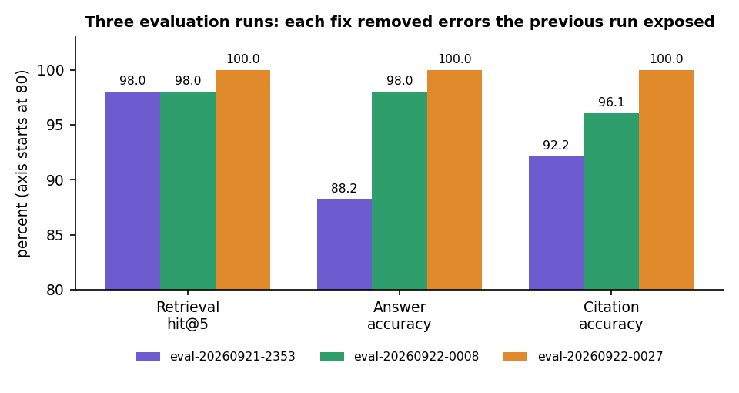
Fig. 1: Improvement across the three evaluation runs

4 Practical Applications
- Policyholders who want to understand what they bought, check a planned claim before filing it, or compare two policies.
- Insurance advisers and customer-service teams who need a fast, cited answer to a wording question.
- Hospitals' insurance desks preparing claim documents (the checklist and steps are generated from the policy).
- Regulators and consumer groups reviewing how clearly policy wordings state waiting periods, sub-limits and exclusions (the risk highlights surface them).
- Teaching retrieval-augmented generation with a real, checkable evaluation.

5 Known Limitations
- The evaluation set is small (51 answerable questions, four policies, 14 claim scenarios) and the abstention thresholds and parser fixes were tuned on it; results on unseen policies are not yet known.
- All results are from the smallest Gemini model in the chain; larger models were not measured.
- The faithfulness score is a heuristic; the translation of the Policy Card into Telugu contained one mixed-script line.
- Plan variants (for example the seven variants in one HDFC ERGO wording) are not yet selectable, so one card value is ambiguous.
- Text-layer English PDFs only; no OCR.
- No user study, no load or security testing.
- No numeric comparison with the base paper is possible, because it summarises Turkish court rulings and reports ROUGE.

6 Future Scope
The items below follow from the limitations and from the gaps found in the literature survey.

7 Improvements
- Evaluate on a fresh, larger question set from policy wordings not used in development, with independent annotators.
- Re-run the evaluation with the larger Gemini models and report the difference.
- Let the user select the plan variant on the Policy Card and use it in answers and claim checks.
- Improve the faithfulness scorer, for example with a larger NLI model or by giving the scorer the clause heading only for inclusion lists.
- Check translation quality automatically (script detection per line) and retry a line that mixes scripts.
- Fix the dashboard tile layout at 1440 px and repeat the accessibility checks.

8 Additional Features
- OCR for scanned policy documents.
- Upload and parsing of non-English wordings and more languages for answers.
- Claim document upload with a check against the generated checklist; reminders for claim deadlines.
- Policy renewal comparison: a changed wording against last year's.
- Hospital network look-up for cashless claims; voice input for questions.

9 Scalability and Deployment
- Replace SQLite and the local vector store with a server database and a hosted vector store for many users.
- Run the three local models in a separate worker service, and queue ingestion with a job system.
- Serve over HTTPS with a generated signing secret, rate limiting and a security review before any shared deployment.
- Add monitoring of model quota, latency and the faithfulness distribution; keep the evaluation as a regression test in continuous integration.
- Measure load and concurrency, which were not tested here.

10 Further Research
- Compare clause-aware segmentation with learned segmentation and with graph-structured retrieval [5] on insurance wordings.
- Calibrate the faithfulness score against human judgement and learn the abstention rule from data instead of two thresholds.
- Study how often retrieval-grounded answers still contain a false statement, as in [2], on health-insurance wordings with a larger panel of expert answers.
- Evaluate whether policyholders make better decisions with the assistant: a user study with real wordings.

REFERENCES
[1] M. A. A. Albayati and O. Findik, "A hybrid transformer-based framework for multi-document summarization of Turkish legal documents," IEEE Access, vol. 13, pp. 37165-37181, 2025, doi: 10.1109/ACCESS.2025.3545750.
[2] D. Beauchemin, R. Khoury and Z. Gagnon, "Quebec automobile insurance question-answering with retrieval-augmented generation," in Proc. Natural Legal Language Processing Workshop (NLLP), Miami, FL, USA, 2024, pp. 48-60, doi: 10.18653/v1/2024.nllp-1.5.
[3] "A medical insurance question answering system based on multi-strategy retrieval-augmented generation," in Proc. 2026 5th Int. Symp. Computer Applications and Information Technology (ISCAIT), 2026 (listed in the batch literature survey; not independently retrieved).
[4] "Artificial intelligence chatbot in Iran Health Insurance Organization: A new era in service providing," Iranian Journal of Health Insurance, 2023 (listed in the batch literature survey; not independently retrieved).
[5] S. Knollmeyer, O. Caymazer and D. Grossmann, "Document GraphRAG: Knowledge graph enhanced retrieval augmented generation for document question answering within the manufacturing domain," Electronics, vol. 14, no. 11, Art. 2102, 2025, doi: 10.3390/electronics14112102.
[6] A. Maharjan and U. Yadav, "Chunking, retrieval, and re-ranking: An empirical evaluation of RAG architectures for policy document question answering," arXiv:2601.15457, Jan. 2026.
[7] P. Lewis et al., "Retrieval-augmented generation for knowledge-intensive NLP tasks," in Advances in Neural Information Processing Systems (NeurIPS), vol. 33, 2020, pp. 9459-9474.
[8] S. Robertson and H. Zaragoza, "The probabilistic relevance framework: BM25 and beyond," Foundations and Trends in Information Retrieval, vol. 3, no. 4, pp. 333-389, 2009.
[9] G. V. Cormack, C. L. A. Clarke and S. Buettcher, "Reciprocal rank fusion outperforms Condorcet and individual rank learning methods," in Proc. 32nd Int. ACM SIGIR Conf. Research and Development in Information Retrieval, 2009, pp. 758-759.
[10] N. Reimers and I. Gurevych, "Sentence-BERT: Sentence embeddings using Siamese BERT-networks," in Proc. EMNLP-IJCNLP, 2019, pp. 3982-3992.
[11] W. Wang, F. Wei, L. Dong, H. Bao, N. Yang and M. Zhou, "MiniLM: Deep self-attention distillation for task-agnostic compression of pre-trained transformers," in Advances in Neural Information Processing Systems (NeurIPS), vol. 33, 2020, pp. 5776-5788.
[12] R. Nogueira and K. Cho, "Passage re-ranking with BERT," arXiv:1901.04085, 2019.
[13] P. He, J. Gao and W. Chen, "DeBERTaV3: Improving DeBERTa using ELECTRA-style pre-training with gradient-disentangled embedding sharing," arXiv:2111.09543, 2021.
[14] A. Williams, N. Nangia and S. Bowman, "A broad-coverage challenge corpus for sentence understanding through inference," in Proc. NAACL-HLT, 2018, pp. 1112-1122.
[15] T. Bajaj et al., "MS MARCO: A human generated machine reading comprehension dataset," arXiv:1611.09268, 2016.
[16] Z. Ji et al., "Survey of hallucination in natural language generation," ACM Computing Surveys, vol. 55, no. 12, Art. 248, 2023.
[17] Gemini Team, Google, "Gemini: A family of highly capable multimodal models," arXiv:2312.11805, 2023.
[18] V. Karpukhin et al., "Dense passage retrieval for open-domain question answering," in Proc. EMNLP, 2020, pp. 6769-6781.
[19] C.-Y. Lin, "ROUGE: A package for automatic evaluation of summaries," in Text Summarization Branches Out, ACL Workshop, Barcelona, Spain, 2004, pp. 74-81.

